UNIVERSITÀ DEGLI STUDI DI BERGAMO
Dipartimento di
Ingegneria Gestionale, dell’Informazione e della Produzione
Corso di laurea in
Ingegneria Informatica
Classe n. L-8 Ingegneria dell’Informazione
Evolution of Cloud Systems and Data Platforms
Candidato:  Davide Falconi | Relatore:  Chiar.mo Prof. Mauro Pelucchi
Matricola n. 1087700

Anno Accademico
2024/2025

Acknowledgments

I would like to dedicate this work to all the people who have accompanied me on this journey.

Special thanks go to my girlfriend, for the love and constant support she has given me in every moment. Having you by my side made everything lighter.

A sincere thank you to my parents for their continued support and for giving me the opportunity to pursue and complete my studies.

To my brother: thank you for always being there whenever I needed help, good advice, or just a meaningful conversation.

A thought goes to my entire family and friends, for the shared moments of joy and for being close to me along the way.

Finally, I would like to thank my supervisor for his guidance and support throughout the development of this thesis.

TABLE OF CONTENTS
Introduction 6
Definitions 8
Chapter I. State of the art: The evolution of Cloud Systems and Data Architectures 9
Chapter II. Strategic challenges survey: Design and methodology 13
Chapter III. Data collection and analysis (preliminary results) 18
Chapter IV. Serverless FinOps prototype development 21
Conclusions 27
References 28

Introduction
The primary objective of this thesis is to analyze the current challenges and future perspectives of modern Cloud Systems and Data Platforms, examining them from both a technological and strategic business standpoint. Furthermore, to bridge the gap between theoretical research and practical application, the final goal of this thesis is to develop a code-based functional prototype to automatically resolve one of the most pressing industry challenges identified during our analysis.

Over the past decade, cloud computing has fundamentally transformed how organizations store, process, and analyze data. The transition from on-premise, monolithic Data Warehouses to flexible Data Lakes, and subsequently to modern Lakehouses and decentralized Data Meshes, has provided unprecedented scalability and agility (Wong, 2023; Harby & Zulkernine, 2022). This evolution successfully addressed the challenges of data volume and compute capacity. However, despite these technological leaps, companies continue to experience significant friction.

The shift from CapEx (capital expenditure) to OpEx (operational expenditure) financial models has led to “Cloud bill shock,” largely due to uncontrolled scaling and orphaned resources (Somajohassula, 2025; Chandrashekhar & Rafika, 2023). Moreover, the move from centralized data monoliths to fragmented, domain-oriented architectures (like the Data Mesh) has expanded the security surface area, turning access control and regulatory compliance into complex operational burdens (Ahmadi, 2024; Rahdari, et al., 2025; Goedegebuure, et al., 2024). The motivation for this work stems from these discrepancies: while cloud architectures are highly mature, the operational disciplines required to manage them, specifically FinOps and automated security governance, often lag behind (Goedegebuure, et al., 2024). This thesis seeks to quantify these pain points in the real world and deploy an actionable, automated solution.

To thoroughly investigate these challenges and deliver a practical solution, the research methodology was structured into four distinct phases:
Knowledge and information gathering: A comprehensive literature review mapping the evolution of data architectures (from Data Lakes to Data Meshes) and identifying major industry friction points based on academic research and state-of-the-art developments.
Questionnaire design: Development of a targeted, quantitative survey aimed at industry practitioners and technical decision-makers (CTOs, Lead Architects). This survey was structured to validate the theoretical challenges encountered in the first phase and measure their real-world severity.
Data collection and processing: Execution of the survey, followed by an analysis of the responses to uncover correlations (e.g., architectural maturity vs. cloud waste) and pinpoint the specific “missing tools” that the industry prioritize.
Prototype development: Based on the insights and demands captured in the survey, the design, implementation, and deployment of a Serverless tool on Amazon Web Services (AWS).

The remainder of this thesis is organized as follows:
- Chapter I: State of the art - traces the historical evolution of cloud data architectures, detailing the transition from Data Lakes to Lakehouses and Data Meshes, and formally defines the persistent challenges of security, FinOps, and interoperability.
- Chapter II: Strategic challenges survey - details the rationale and design of the quantitative questionnaire used to validate our hypotheses with industry experts.
- Chapter III: Data collection and analysis - presents the results gathered from the survey, interpreting the data to confirm the operational burdens of modern cloud systems and identify the most critical tooling gaps.
- Chapter IV: Serverless FinOps prototype development - outlines the architecture, implementation details, and security guardrails of the AWS-based functional prototype chosen in Chapter III.

Definitions
1. Enterprise Data Warehouse (EDW)
An Enterprise Data Warehouse is a centralized, structured repository designed to store and manage large volumes of historical data from multiple sources across an organization. Data must be cleaned, transformed, and modeled into a predefined schema before it can be ingested, imposing significant upfront effort in data modeling and making it difficult to accommodate rapidly changing or unstructured data formats, such as logs, images, or sensor streams.

2. Data Lake
A Data Lake is a large-scale storage system designed to hold vast amounts of raw data in its native format, regardless of its structure. Data is ingested as-is, and structure is applied only at the moment of analysis, providing exceptional flexibility and cost efficiency.

3. Lakehouse
The Lakehouse is a modern data architecture that combines the flexibility and low-cost storage of the Data Lake with the data management and performance features of the Data Warehouse. Lakehouses bring ACID transactional capabilities to open file formats stored on object storage, ensuring data reliability without sacrificing the openness of the underlying storage layer.

Chapter I. State of the art: The evolution of Cloud Systems and Data Architectures
Figure 1: Visual representation of Data Lake, Data Lakehouse and Data Mesh
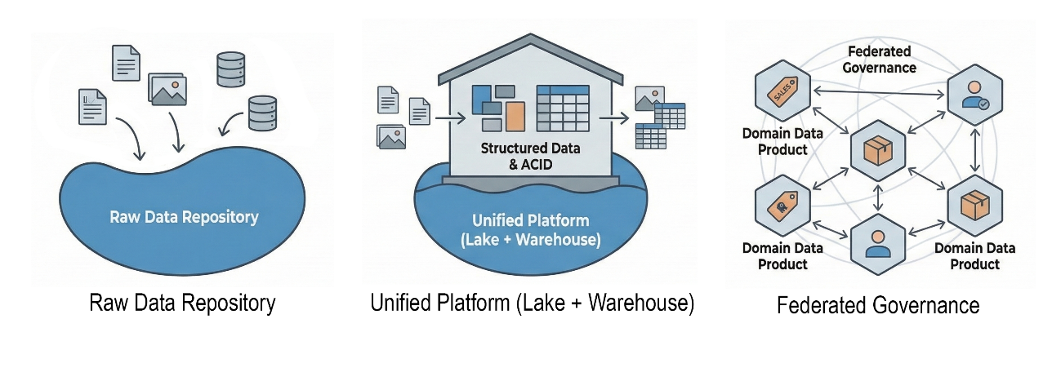
Source: Author’s elaboration

1. The era of Data Lake (2010-2015)
Before the dominance of the cloud, the Enterprise Data Warehouse (EDW) was the standard. EDWs relied on “Schema-on-Write”, requiring data to be modeled before ingestion. While highly structured, this approach failed to keep pace with the explosion of unstructured data (logs, media, sensor data) driven by Industry 4.0 (Harby & Zulkernine, 2022; Kretzer, Benitti, & Siqueira, 2025; Wong, 2023).
The industry responded with the Data Lake. Built largely on the Hadoop Distributed File System (HDFS) and utilizing the MapReduce programming model, the Data Lake introduced the concept of “Schema-on-Read”. This allowed organizations to ingest raw data in its native format and apply structure only when the data was queried (Wieder & Nolte, 2022; Harby & Zulkernine, 2022).
However, without the rigid governance of the warehouse, Data Lakes often became dumping grounds for uncatalogued, low-quality data, called “Data Swamps” (Wieder & Nolte, 2022). While Data Lakes solved the problem of storage cost and volume, they struggled with data discovery, reliability, and the complexity of maintaining on-premise Hadoop clusters.

2. The modern data stack and the Lakehouse (2015-2020)
The mid-2010s marked the transition to cloud-native architectures. The defining technological breakthrough of this period was the separation of compute and storage. Cloud providers (such as AWS, Azure and Google Cloud) allowed organizations to store infinite data cheaply while spinning up transient compute clusters only when processing was required (Harby & Zulkernine, 2022; Wong, 2023).
This era saw the rise of the Data Lakehouse, which sought to unify the best features of the Data Warehouse (reliability and performance) with the flexibility of the Data Lake (Harby & Zulkernine, 2022).
- Transactional capabilities: Unlike early Data Lakes, Lakehouses introduced ACID transactions to object storage.
- Unified workloads: They enabled BI and AI/ML workloads to operate on the same data copy, eliminating the need to maintain separate silos (Rella, 2025).
Despite these leaps, the organizational bottleneck remained. The architecture was fundamentally centralized, with a single data engineering team responsible for ingesting and cleaning data for the entire organization (Goedegebuure, et al., 2024).

3. Decentralization and Data Mesh (2020-present)
The centralization of data teams became a bottleneck that slowed down domain-specific innovation. The solution proposed was the “Data Mesh”, a socio-technical shift based on four foundational principles (Goedegebuure, et al., 2024):
- Domain-oriented decentralization: Ownership of data is pushed to the business domains (for example, marketing, sales, logistics) that understand the data best.
- Data as a product: Domains treat their data assets as products with consumers, ensuring quality and documentation.
- Self-serve data infrastructure: A central platform team provides the tooling for domains to spin up their own data products easily.
- Federated computational governance: Global standards (security, interoperability) are applied automatically to prevent chaos.
An extension of this decentralization is the concept of Dataspaces, a digital environment facilitating secure data sharing between organizations (VisionsPol, 2024). While Data Mesh offers a path to scalability, it introduces significant complexity regarding interoperability and governance (Goedegebuure, et al., 2024; Wong, 2023).

4. Beyond the modern data stack (future)
Recent innovations suggest a move beyond the standard Lakehouse model towards even more specialized and AI-integrated architectures.
- AI-native warehouses and Vector Search: Modern systems are embedding ML primitives directly into the database engine. Platforms like Google BigQuery are integrating Vector Search capabilities, enabling semantic search and RAG directly on the Data Warehouse (United States of America Patent No. US11954112B2, 2024; Google Cloud, 2026).
- Disaggregated executions: Query execution is broken down into fine-grained tasks that access shared storage asynchronously and in parallel, allowing for extreme elasticity (United States of America Patent No. US12271375B2, 2025).
- Ray vs Spark: Ray is emerging as a preferred “AI Compute Engine”. While Spark is optimized for bulk-synchronous parallel data tasks, Ray provides a more flexible, actor-based, asynchronous runtime better suited for distributed AI training and serving (Ray, n.d.).

5. Critical challenges: Security, FinOps, and vendor lock-in
While the transition to cloud and decentralized architectures solves scalability and hardware maintenance, it introduces new “friction points”, specifically security, cost, and vendor lock-in.

- Security and governance in a fragmented landscape: The shift from a centralized “fortress” to a decentralized mesh creates a massive surface area for security vulnerabilities (Ahmadi, 2024; Rahdari, et al., 2025). Access control policies must be propagated across hundreds of data products and microservices. Federated learning and policy-as-code might be emerging solutions (Rahdari, et al., 2025), but ensuring regulatory compliance when data ownership is distributed remains a challenge (Goedegebuure, et al., 2024).
- Economic pressures (FinOps): Operating models have moved from CapEx (capital expenditure) to OpEx (operational expenditure), paying monthly for usage. The variable nature of cloud costs means a poorly written query or an orphaned cluster can result in massive expenses (“Cloud Bill Shock”) (Somajohassula, 2025). This necessitated the rise of FinOps, a cultural practice where engineering teams take ownership of their cloud costs (Somajohassula, 2025; Chandrashekhar & Rafika, 2023).
- Vendor lock-in and interoperability: Organizations heavily relying on proprietary cloud services face vendor lock-in (Ganesan, 2025). While multi-cloud strategies are conceptually attractive, they are difficult to implement due to data gravity and egress fees (Ganesan, 2025). To mitigate this, standard Open Table Formats (like Apache Iceberg, Delta Lake, or Apache Hudi) allow data to be stored in open standards, making it readable by different compute engines across clouds, although true interoperability remains a hurdle (Hübschle, 2025).

Chapter II. Strategic challenges survey: Design and methodology
This chapter outlines the research methodology and the design of the quantitative survey utilized to collect primary data for this thesis. Building upon the theoretical and architectural challenges discussed in Chapter I, this phase aims to investigate how modern organizations manage cloud systems and data platforms in practice. By defining a precise sampling strategy and systematically gathering feedback from industry experts, the objective is to translate theoretical friction points into measurable metrics. The methodology encompasses the construction of the dataset, the definition of the target audience, and the structural design of the questionnaire itself.

Figure 2: Survey preview
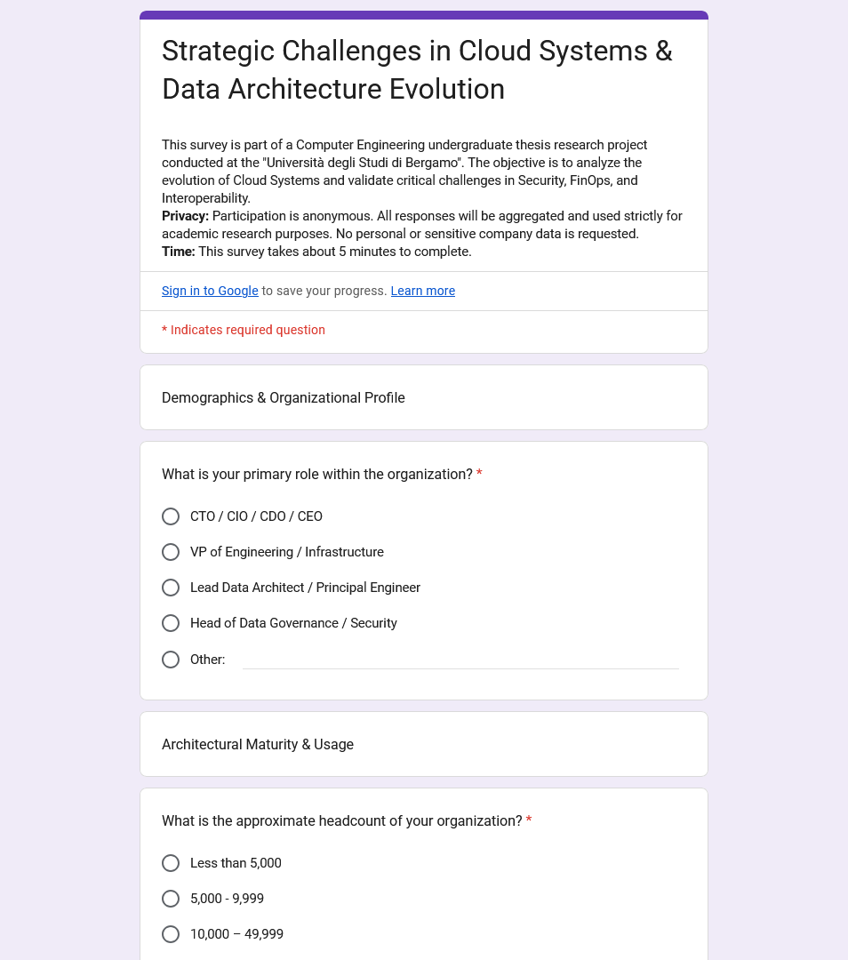
Source: Strategic Challenges in Cloud Systems and Data Architecture Evolution Survey
The second phase of this research involves a targeted quantitative survey titled “Strategic Challenges in Cloud Systems and Data Architecture Evolution”. The primary objective is to validate the theoretical friction points identified in Phase 1 against real-world data from industry practitioners, focusing on the severity and context of those challenges. The survey is designed to move beyond anecdotal evidence and provide statistical backing for the hypothesis that current cloud data platforms suffer from significant fragmentation and governance overhead.
Specific research goals for this phase include:
- Correlating maturity with governance challenges: Determining if advanced architectures (e.g., Data Mesh) actually reduce friction or introduce new complexities.
- Quantifying “hidden” costs: Assessing the impact of elusive metrics like “orphaned resources” and cognitive load on productivity.
- Identifying the Market Gap: Discovering which “missing tools” practitioners prioritize, directly guiding the prototyping stage.

2.1. Dataset construction and sampling strategy
To ensure that the survey reached professionals with direct experience in cloud data management, a rigorous and structured sampling strategy was employed. The population of interest consisted of mid-to-senior technical professionals (such as CTOs, Lead Architects, and Heads of Data Governance) working at companies that actively operate within the information technology sector. Specifically, the sampling strategy targeted companies classified under the NACE (Nomenclature of Economic Activities) codes 62, 63, 64, and 65. Furthermore, to guarantee that the selected organizations possessed sufficient scale and architectural complexity to encounter the enterprise-grade challenges under investigation, a minimum threshold of 1000 employees was established.

2.2. Orbis: the data source
The primary data source used to build the target company list was Orbis, a highly comprehensive global business intelligence platform published by Bureau van Dijk (a Moody's Analytics company). Orbis aggregates financial, organizational, and contact information for hundreds of millions of companies worldwide, making it one of the most powerful and relevant tools for market and academic research. The platform integrates data from numerous public and proprietary sources, including official business registers, annual filings, news feeds, and professional networks, providing a unified and standardized view of any given company's profile. Orbis was strategically chosen over other databases not only because of its unparalleled breadth and precise filtering capabilities, which are essential for isolating large enterprises, but also because free, full access to its premium corporate information database was available through the university's academic license. This provided an invaluable opportunity to construct a high-quality dataset natively embedded within an academic research framework.

2.3. Company selection criteria
Using the filtering tools provided by Orbis, specific selection criteria were applied to construct a precise list of target companies. These criteria were chosen to specifically isolate enterprises that are statistically more likely to have transitioned to modern cloud architectures and therefore experience the data governance and FinOps challenges analyzed in this research. The criteria were:
- Industry: Companies strictly classified under NACE codes 62, 63, 64, and 65. This ensures that the respondents operate within IT and closely related data-intensive domains.
- Headcount: A strict minimum threshold of 1000 employees was imposed. This criterion was chosen because large-scale organizations are significantly more likely to possess the architectural complexity and cloud infrastructure footprint required to provide meaningful insights for this study.
- Geography: The search was conducted with a global scope in order to capture diverse perspectives and avoid regional bias.

2.4. Survey distribution
Once the target list was compiled, the survey was distributed via email to the professional contacts of individuals working within the selected companies. Approximately 10,000 email addresses were sourced directly from the Orbis and Lightcast Rethorik databases, which list professional contacts along with their roles within the organization. Priority was given to reaching individuals in technical leadership roles (e.g., CTO, VP of Engineering, Lead Architect, Head of Data Governance), consistent with the target audience defined above.
Each email contained a brief introduction to the research project, a reference to the university, and a direct link to the Google Forms questionnaire.

2.5. Target audience and ethical considerations
Target audience: The survey targets technical decision-makers and senior engineers (CTOs, Lead Architects, Heads of Data Governance) rather than junior developers. This ensures responses reflect a strategic, organizational view rather than just individual contributor pain points.
Privacy and ethics: To encourage honest transparency regarding sensitive topics like security failures or wasted budget, the survey is strictly anonymous. No personally identifiable information or sensitive company data is collected.

2.6. Survey structure and analytical rationale
The questionnaire is structured into four logical sections, each designed to test specific hypotheses.

Section 1: Demographics and organizational profile
Rationale: To normalize the data. Responses regarding “cloud waste” or “governance difficulty” vary wildly between a 50-person startup and a 100,000-employee enterprise. Collecting role and headcount allows us to segment the analysis (e.g., “Does FinOps maturity correlate with company size?”).

Section 2: Architectural maturity and usage
Rationale: To classify the respondent's technical environment. We need to distinguish between legacy on-premise constraints and modern cloud-native challenges.
Key insight sought: By asking about their specific architecture (Data Lake vs. Lakehouse vs. Mesh) and cloud strategy (single vs. multi-cloud), we can cross-reference significantly different friction points. For instance, we hypothesize that multi-cloud organizations will report higher difficulty in IAM consistency than single-cloud ones.

Section 3: Validating Friction Points
This section forms the core of the problem validation, using Likert scales to quantify subjective pain points.
- Security policies: The goal is to measure the operational burden of security. If respondents rate “enforcing consistent policies” as highly difficult, it validates the need for the “automated policy propagation” tool.
- Governance in decentralization: We categorize the biggest challenges (IAM inconsistency vs. visibility vs. compliance) to pinpoint exactly where decentralization breaks down.
- FinOps maturity: By classifying cost management into reactive (Bill Shock), proactive, or automated, we assess the market readiness for automated cost-saving tools.
- Orphaned resources: This directly validates the “AutoStop” prototype concept. If respondents indicate significant waste from idle resources, the value proposition of an automated cleanup tool is confirmed.

Section 4: Interoperability and vendor lock-in
Rationale: To understand the barriers to data liquidity.
Key investigation: We investigate whether egress fees, data gravity, or formats are the primary blocker. Additionally, understanding the adoption of Open Table Formats (Iceberg/Delta) helps predict the future relevance of vendor-neutral tools.

Section 5: Prototype discovery and future outlook
Rationale: We explicitly ask practitioners which tool would provide the highest value.
Outcome: The winning option among “Automated Policy Propagation”, “Cost Anomaly Prevention”, etc., will directly dictate the functional prototype developed in the final phase of this thesis.

Chapter III. Data collection and analysis (preliminary results)
The purpose of this phase is to extract actionable insights from the survey outlined in the previous chapter, validating the theoretical challenges of modern cloud systems against real-world, empirical data. It must be noted that the following results are preliminary, as they are based on an initial pool of 20 responses from industry professionals. The data collection and the overall work will be completed in the next few months. Despite the limited sample size, the data exhibits clear trends that support the hypotheses regarding FinOps inefficiencies and governance overhead.

3.1. Respondent Demographics and architectural profiles

Figure 3: Survey results, first graph
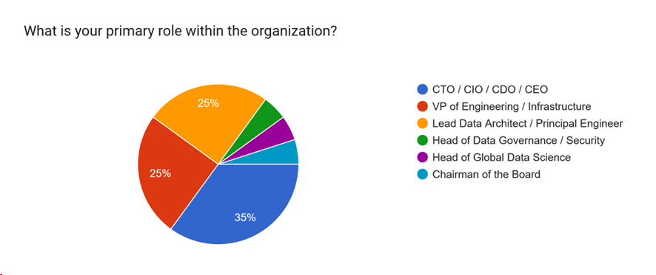
Source: Strategic Challenges in Cloud Systems and Data Architecture Evolution Survey

The survey successfully engaged technical decision-makers and senior engineers.
- Roles: The respondents included CTOs/CIOs, Lead Data Architects/Principal Engineers, VPs of Engineering/Infrastructure, Heads of Data Governance/Security, and Board Members.
- Organization size: A substantial 45% of respondents operate in enterprises with 10,000 to over 100,000 employees, ensuring that the reported challenges reflect enterprise-level architectural complexities. The remainder comprises organizations with fewer than 10,000 employees.
- Architecture: Centralized Data Lakes emerged as the most prevalent architecture (45%), followed closely by Lakehouses (30%). Decentralized Data Meshes are currently deployed by 10% of the sample, while 15% still operate on Legacy/Monolithic EDWs.

3.2. Validating Friction Points

Figure 4: Survey results, second graph
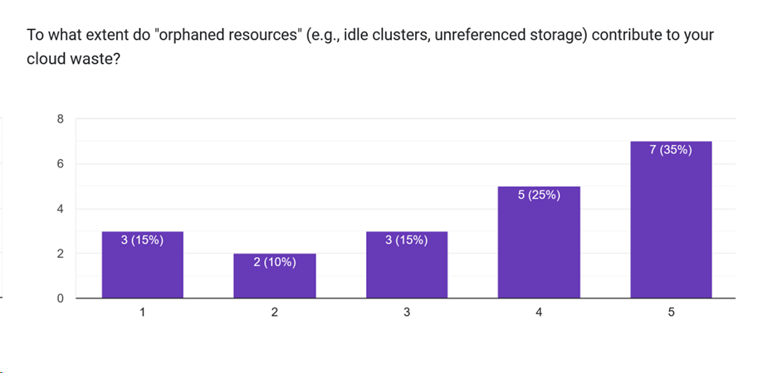
Source: Strategic Challenges in Cloud Systems and Data Architecture Evolution Survey

Respondents were asked to rate the difficulty of enforcing consistent security policies across their data estates on a scale of 1 to 5. The average score was 3.65, indicating a moderate to high level of difficulty.
In decentralized or self-service environments, the primary governance challenges reported were:
- Ensuring regulatory compliance (GDPR/HIPAA) across independent teams (40%).
- Achieving consistent access control (IAM) across different domains (35%).
- A lack of visibility regarding data access (15%).
This data confirms that while architectural decentralization may resolve scalability bottlenecks, it significantly amplifies the operational burden of securing data access.

Cost management practices reveal a maturity gap within the industry. A significant 40% of organizations still operate reactively, analyzing bills at the end of the month and dealing with “Bill Shock.” Another 40% utilize proactive but manual measures, such as quotas and budget alerts. Only 15% practice true FinOps, where engineering teams have direct accountability for the unit costs of their workloads.
Crucially, when asked to rate the extent to which “orphaned resources” (e.g., idle compute clusters) contribute to their cloud waste (on a 1 to 5 scale), the average response was 3.55. This validates the core hypothesis of this research: organizations struggle to identify and decommission unused resources, resulting in substantial financial inefficiency.

3.3. Identification of the Market Gap
The final section of the survey directly asked practitioners to identify which “missing tool” would provide the highest value to their organization today.
- The most requested tool, selected by 55% of respondents, was “Idle Resource Auto-Termination: A script that identifies and decommissions underutilized resources automatically.”
- “Proactive Cost Anomaly Prevention” (simulating queries before execution) was the second most requested at 30%.
- “Automated Policy Propagation” and “Data Product Marketplaces” constituted the remaining 15%.
The preliminary survey results decisively validate the targeted friction points. The explicit, data-driven demand for an Idle Resource Auto-Termination tool provides a clear mandate for the prototype development in Phase 4: an automated FinOps solution capable of halting resource wastage.

Chapter IV. Serverless FinOps prototype development
4.1. Problem and Objective
The evolution of data platforms, transitioning from centralized architectures to decentralized Data Meshes, has provided organizations with unprecedented scalability. However, as established by the preliminary results from Chapter III, this agility often leads to significant financial inefficiency. Uncontrolled cloud costs, driven largely by “orphaned” or idle computational resources, represent a primary friction point for modern cloud environments. These resources are often provisioned for transient workloads, development environments, or testing phases, but are frequently left running indefinitely once the task is complete. Consequently, they accrue ongoing operational expenditures (OpEx) without concurrently delivering any business value. The lack of proactive visibility and automated FinOps governance exacerbates this “Cloud bill shock”, making it challenging for teams to align cloud consumption with efficient financial practices.
The primary objective of this phase is to move beyond theoretical analysis and develop a functional, code-based prototype specifically designed to address this critical resource wastage. The goal is to demonstrate how automated governance policies can be directly and securely injected into a cloud ecosystem to proactively remediate financial inefficiencies, without imposing additional management overhead or compromising system stability.
The resulting solution is a serverless FinOps AutoStop automation tool. Deployed natively on Amazon Web Services (AWS), the tool is engineered to automatically identify and safely shut down idle Amazon EC2 instances. By leveraging a highly scalable, event-driven architecture, the system ensures that compute costs are incurred strictly when resources are actively utilized. This practical implementation addresses the explicit market demand identified in the survey, proving that targeted, serverless automation is an effective mechanism to bridge the gap between complex cloud capabilities and sustainable, cost-aware operational management.

4.2. Architecture and Implementation Details
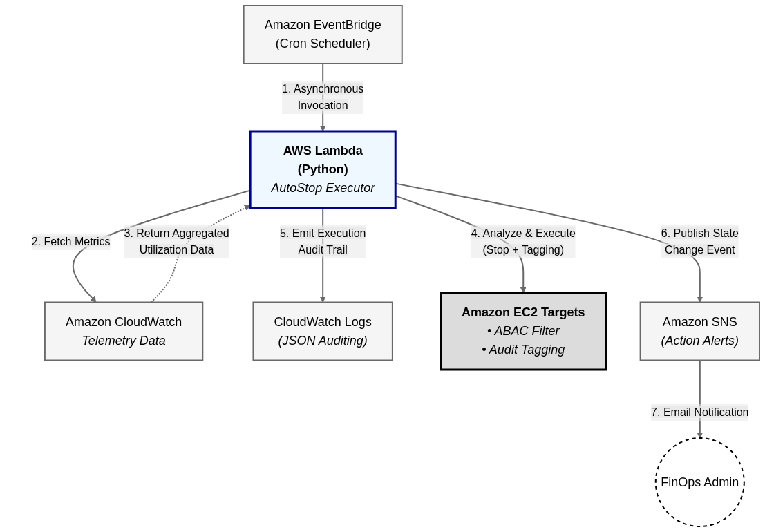
To ensure the solution adheres to FinOps principles (avoiding “FinOps for FinOps” overhead), the tool is constructed using a Serverless architecture.
- Compute: The core logic executes entirely within AWS Lambda, a stateless and ephemeral compute service, eliminating the need for a dedicated, always-on management server.
- Automation: Amazon EventBridge schedules the continuous execution of the Lambda function.
- Configuration: The infrastructure is defined using Infrastructure as Code (AWS SAM).
The core logic of the Python implementation (‘autostop.py’) revolves around a multi-dimensional idle detection system. An instance is flagged as idle only if it simultaneously exhibits low CPU utilization, minimal network traffic, and insignificant disk I/O over a configurable lookback window.
To implement this reliably, the code aggregates multiple metrics from CloudWatch. The following snippet illustrates how the system processes individual instances, incorporating the multi-dimensional check.

def process_instance(instance: Dict[str, Any], request_id:
str = “N/A”) -> str:
# ... guardrails omitted ...
metrics = get_aggregated_metrics(inst_id)
if not metrics:
return “SKIP_METRIC_ERROR”
cpu_max = metrics.get('cpu', 100.0)
net_total = metrics.get('net_in', 0) +
metrics.get('net_out', 0)
disk_total = (metrics.get('disk_read', 0) +
metrics.get('disk_write', 0) +
metrics.get('ebs_read', 0) + metrics.get('ebs_write', 0))
is_idle = (cpu_max < CPU_THRESHOLD) and \
(net_total < NETWORK_BYTES_THRESHOLD) and \
(disk_total < DISK_BYTES_THRESHOLD)
if is_idle:
# Trigger instance stop sequence
ec2.stop_instances(InstanceIds=[inst_id])
return “STOPPED”
return “ACTIVE”

4.3. Reliability, Guardrails, and Results
A vital aspect of automating infrastructure is ensuring that the automation itself does not induce outages. The implementation enforces several critical guardrails:
- Attribute-Based Access Control (ABAC): The system strictly targets only instances explicitly tagged with ‘AutoStop: true’.
- Manual Override: Instances tagged with ‘KeepAlive: true’ are unconditionally skipped, providing operations teams with a mechanism to temporarily bypass automation during critical maintenance windows.
- Spot Instances and ASGs: The script inherently skips Spot Instances and entities belonging to Auto Scaling Groups to prevent unintended termination or respawning loops.
To prioritize reliability over cost savings during failure modes, the system implements a “Fail-Open” design. If the monitoring data is unavailable due to an API error, the system defaults to assuming the instance is busy, as observed in the ‘get_aggregated_metrics’ function:

try:
response = cw.get_metric_data(
MetricDataQueries=metric_queries,
StartTime=start_time, EndTime=end_time
)
except ClientError as e:
logger.error(f”Failed to fetch metrics: {e}”)
return {} # Empty return triggers fail-open strategy

If ‘metrics’ evaluates to false, the system safely aborts the stop action.
Upon successfully halting an idle instance, the system integrates with Amazon SNS to dispatch a real-time email notification to the stakeholders. This notification includes critical metadata (such as instance ID, owner, and timestamp) providing immediate visibility into the automated cost-saving actions and allowing teams to track which resources were stopped.

The result is a low-latency, highly parallelized (via ‘ThreadPoolExecutor’) Serverless application that demonstrates how automated governance can be effectively injected into a cloud environment to directly remediate financial waste without compromising system stability.

4.4. Future Work
The prototype developed in this study represents a foundational step towards automated cloud governance. However, the rapidly evolving nature of cloud environments and the feedback loop from ongoing organizational usage suggest several avenues for future research and development. In particular, as the remaining data from the broader industry survey is collected and analyzed over the coming months, the requirements for this FinOps tool will be further refined to address the complete spectrum of industry needs.
Currently, for future iterations of this prototype, the following main enhancements have been identified to increase its efficiency, usability, and scope:
- Cross-instance metric batching: The current implementation polls CloudWatch metrics for each instance individually. While functional for a prototype, this approach does not scale cost-effectively for enterprise environments with thousands of concurrent instances. Future versions will consolidate CloudWatch queries to batch multiple instances per API call. This architectural optimization will significantly reduce the number of API requests, thereby directly lowering the monitoring overhead costs and enhancing the tool’s adherence to FinOps principles.
- Hibernation support: The prototype currently executes a full shutdown of idle EC2 instances. While this stops compute charges, the subsequent boot sequence can introduce latency and disrupt in-memory operations for developers when they resume work. Extending the logic to support EC2 hibernation would preserve the instance's RAM contents to the root Amazon EBS volume. This would allow for a much faster, seamless resumption of workloads, striking a better balance between aggressive cost-saving measures and developer productivity.
- Owner notification and approval workflows: Currently, notifications are passively sent via email after an instance is stopped. Integrating the tool directly with real-time communication platforms like Slack or Microsoft Teams, using the instance's tagging metadata to pinpoint the exact owner, would drastically improve visibility. Furthermore, this integration could evolve from passive notification to active “ChatOps”. Before stopping an instance, the system could send an interactive ping to the owner, allowing them to explicitly approve the shutdown or request a temporary extension with a single click.
- Multi-cloud extensibility: While the prototype is deeply integrated with the AWS ecosystem (using Lambda, EventBridge, and CloudWatch), the survey highlighted that multi-cloud operations are prevalent challenges. A natural evolution for this tool would be abstracting the core idle-detection logic to support multi-cloud deployments. By integrating with provider-agnostic metrics APIs and supporting Microsoft Azure Virtual Machines or Google Cloud Compute Engine instances, the solution could govern decentralized, heterogeneous environments uniformly.
- Predictive anomaly detection: Expanding beyond static, threshold-based idle detection (which requires manual configuration of CPU and network limits), future work could incorporate lightweight analysis models to evaluate historical usage patterns. This predictive approach would dynamically adjust thresholds based on the specific behavior of each workload, minimizing false positives and further refining the cost-saving automation.

Conclusions
This thesis has explored the evolution and current state of cloud data architectures, highlighting the strategic and operational challenges organizations face today. The historical transition from centralized Enterprise Data Warehouses (EDWs) to flexible Data Lakes, unified Lakehouses, and decentralized Data Meshes has successfully addressed past limitations in data volume, scalability, and compute capacity. However, as demonstrated in this study, this continuous evolution has introduced new friction points, most notably regarding security governance, data interoperability, and financial management (FinOps).
Through a targeted quantitative survey of industry experts, this research empirically validated that organizations struggle significantly with modern cloud cost management. The preliminary results revealed a prevalent lack of FinOps maturity, with a substantial portion of cloud waste being directly attributed to orphaned and underutilized compute resources. Crucially, the survey identified a clear, data-driven market demand for automated solutions to mitigate these financial inefficiencies.
In response to these findings, the final phase of this work successfully developed and demonstrated a Serverless FinOps AutoStop prototype deployed on AWS. By continuously analyzing multi-dimensional telemetry, such as CPU, network, and disk activity, the tool proactively identifies and halts idle instances. Built with strict reliability guardrails and a fail-open design, the prototype effectively reduces cloud waste while maintaining operational stability. In conclusion, while modern cloud data platforms offer unprecedented technological agility, their sustainable adoption is heavily dependent on the integration of automated governance. The functional prototype developed herein proves that targeted, serverless automation is a viable and highly effective approach to bridging the gap between complex cloud capabilities and cost-aware operational management. As cloud architectures continuously evolve to meet new operational demands, the pursuit of a perfectly optimized, self-governing ecosystem remains an ongoing journey. After all, in the relentless drive for technological innovation, people's dreams never end.

References
Ahmadi, S. (2024). Systematic Literature Review on Cloud Computing Security: Threats and Mitigation Strategies. Journal of Information Security, 148-167.
Behzadi, H., Abbo, E. Y., Siebel, T. M., Coker, J., Kurinskas, S., Rothwein, T., & Tchankotadze, D. (2024). United States of America Patent No. US11954112B2.
Chandrashekhar, S. B., & Rafika, I. M. (2023). Cloud Computing Impacts on Business Models: A study based on Osterwalder's Business Model Canvas. DiVA Portal.
Ganesan, A. P. (2025). Evaluation of Multi-Cloud Strategies and Challenges in Small Scale Organizations. ResearchGate.
Goedegebuure, A., Kumara, I., Driessen, S., Di Nucci, D., Monsieur, G., van den Heuvel, W.-J., & Tamburri, D. A. (2024). Data Mesh: a Systematic Gray Literature Review. ACM Computing Surveys, 1-36.
Google Cloud. (2026). Search embeddings with vector search. Retrieved from Google BigQuery Documentation: https://docs.cloud.google.com/bigquery/docs/vector-search
Harby, A. A., & Zulkernine, F. H. (2022). From Data Warehouse to Lakehouse: A Comparative Review. 2022 IEEE International Conference on Big Data. IEEE.
Hübschle, L. (2025). Querying Apache Iceberg with Sub-Second Performance. Retrieved from Firebolt Blog: https://www.firebolt.io/blog/querying-apache-iceberg-with-sub-second-performance
Kretzer, A. R., Benitti, F. B., & Siqueira, F. (2025). Challenges and Opportunities in Big Data Analytics for Industry 4.0: A Systematic Evaluation of Current Architectures. IEEE Access, 183-192.
O'Krafka, B. W., Busch, J. R., Krishnan, M., & Rothauge, K. (2025). United States of America Patent No. US12271375B2.
Rahdari, A., Keshavarz, E., Nowroozi, E., Taheri, R., Hajizadeh, M., Mohammadi, M., . . . Bauschert, T. (2025). A Survey on Privacy and Security in Distributed Cloud Computing: Exploring Federated Learning and Beyond. IEEE Open Journal of the Communications Society, 3710-3744.
Ray. (n.d.). Ray: The AI Compute Engine. Retrieved from Ray: https://www.ray.io/
Rella, B. P. (2025). Comparative Analysis of Data Lakes and Data Warehouses for Machine Learning. International Journal for Multidisciplinary Research.
Somajohassula, D. K. (2025). Financial Cloud Cost Optimization: A FinOps Framework for Modern Financial Institutions. World Journal of Advanced Research and Reviews, 2620-2631.
VisionsPol. (2024). Everything you need to know about data spaces: simplified access and shared AI data services. Retrieved from VisionsPol: https://visionspol.eu/en/2024/11/20/everything-you-need-to-know-about-data-spaces-simplified-access-and-shared-ai-data-services/
Wieder, P., & Nolte, H. (2022). Toward data lakes as central building blocks for data management and analysis. Frontiers in Big Data. Retrieved from Frontiers in Big Data.
Wong, B. (2023). Navigating the Data Architecture Landscape: A Comparative Analysis of Data Warehouse, Data Lake, Data Lakehouse, and Data Mesh. Current Trends in Computer Sciences & Applications.

https://aws.amazon.com/
https://www.databricks.com/blog/what-is-edw
https://cloud.google.com/learn/what-is-a-data-lake
https://cloud.google.com/discover/what-is-a-data-lakehouse
https://hadoop.apache.org/
https://azure.microsoft.com/
https://cloud.google.com/
https://www.datamesh-architecture.com/
https://cloud.google.com/bigquery
https://github.com/ray-project/ray
https://spark.apache.org/
https://iceberg.apache.org/
https://delta.io/
https://hudi.apache.org/
https://www.moodys.com/web/en/us/capabilities/company-reference-data/orbis.html
https://workspace.google.com/products/forms/
https://aws.amazon.com/lambda/
https://aws.amazon.com/eventbridge/
https://aws.amazon.com/serverless/sam/
https://www.python.org/
https://aws.amazon.com/cloudwatch/
https://aws.amazon.com/it/sns/

